The programming was started by placing the cylindrical specimen (~6 mm of diameter, ~9mm of height) in between the MTS clamps and thermally equilibrated at 275 °C for 1 h. Then the cylinder was compressed to 34.5% strain at a speed of 0.5 mm/min and maintained for 10 min. After that, the compressed cylinder was rapidly cooled to room temperature by spraying water, followed by load removal. The height of the programmed specimen was recorded to figure out the shape fixity ratio. The free shape recovery experiment was conducted by putting the programmed specimen in an oven at 275 °C for 60 min. The height of the recovered specimen was measured to calculate the shape recovery ratio. Figure 1 and 2 shows the programming of the HTSMP-2 sample. Again, it is noted that the cooling stage and load removal stage were basically a vertical line in the compression stress-strain curve due to the quick cooling and load removal during programming. Based on the test results, the fixed strain was 20 %, the shape fixity ratio was 58%, and the free recovery ratio was 93.1 %. Again, these results show that HTSMP-2 is an excellent shape memory polymer. Figure 3 shows the original shape and programmed shape of a specimen cured by UV only.
Figure 1: Shape programming curves of UV cured sample at 160ºC. The programming strain is 35.5%.
Figure 2: Shape programming curves of HTSMP (UV curing + 280ºC for 3 h) at 275ºC. The programming strain is 34.5%.
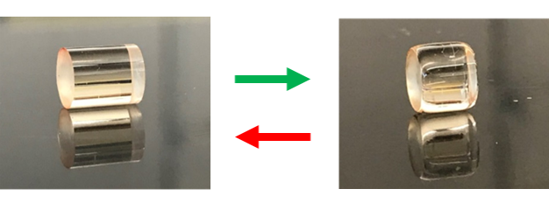
Figure 3: The original shape (right) and the shape after compression programming (left) for a specimen cured by UV only.

